Breakfast Burrito

Prep time: 10mins

Serves: 4

Description
Eggs are highly nutritious - packed with vitamins and minerals, high in protein, contain healthy fats and important antioxidants.
Kick start your day with this Mexican inspired delicious egg recipe!

Ingredients
4 |  | Eggs (lightly beaten)
1⁄4 | Cup | reduced fat milk
1 | Cup | corn kernels
2 | Tablespoon | red capsicum (finely diced)
2 | Tablespoon | green capsicum (finely diced)
 |  | white pepper (to taste)
100 | grams | button mushrooms (quartered)
4 |  | whole flour tortillas (warmed)
2 |  | medium tomatoes (slices)
1 | Cup | reduced fat cheddar cheese (grated)

Notes
For adults: Add a dash of tabasco sauce to the omelette mixture.

Instructions
1. Lightly whisk eggs, milk, corn, capsicum and pepper together.
2. Pour one quarter of the egg mixture into a small pre-heated non-stick frypan to just cover the base. Cook over medium heat until eggs are almost set. Turn over and cook for a further 15 seconds. Repeat with remaining mixture to make 4 omelettes.
3. Cook mushrooms in the same frypan until golden.
4. Top each tortilla with a cooked omelette, sliced tomato, mushrooms and cheese. Fold the edge closest to you over one third of the filling and then fold in the sides of the tortilla to form a burrito

(NutritionAustralia, n.d.)

Breakfast Smoothies
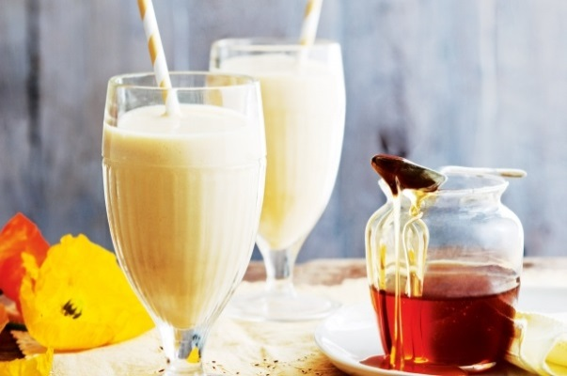
Mango, almond and honey breakfast smoothie
- Ingredients
- Nutrition
- Specials
- 1 mango
- 400ml skim milk
- 1/2 cup low-fat natural yoghurt
- 2 tablespoons almond meal
- 1 tablespoon Manuka honey
- Ice cubes
Step 1: Peel and chop mango and place in a blender with skim milk, low-fat natural yoghurt, almond meal, manuka honey and a few ice cubes.
Step 2: Blend until smooth. Divide between 2 glasses.

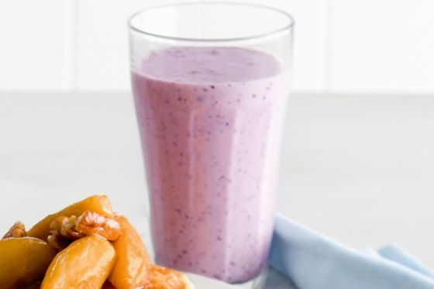
Banana, oat and blueberry breakfast smoothie
- Ingredients
- Nutrition
- Specials
- 1/2 cup traditional rolled oats
- 2 ripe bananas
- 1/2 cup frozen blueberries
- 2 teaspoons LSA (see note)
- 1 cup reduced-fat milk
- 1 cup reduced-fat plain Greek-style yoghurt
- 2 teaspoons honey
Step 1
Blend oats, banana, blueberries, LSA, milk, yoghurt and honey together until smooth. Pour into chilled glasses. Serve.

(Taste.com, 2014)

Broccoli & Feta Omelette with Toast
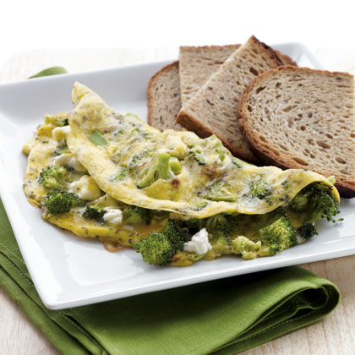

Ingredients
- Cooking spray
- 1 cup chopped broccoli
- 2 large eggs, beaten
- 2 tablespoons feta cheese, crumbled
- 1/4 teaspoon dried dill
- 2 slices rye bread, toasted

Preparation
1. Heat a nonstick skillet over medium heat. Coat pan with cooking spray. Add broccoli, and cook 3 minutes.
2. Combine egg, feta, and dill in a small bowl. Add egg mixture to pan. Cook 3 to 4 minutes; flip omelet and cook 2 minutes or until cooked through. Serve with toast.

Breakfast Barley with Banana & Sunflower Seeds
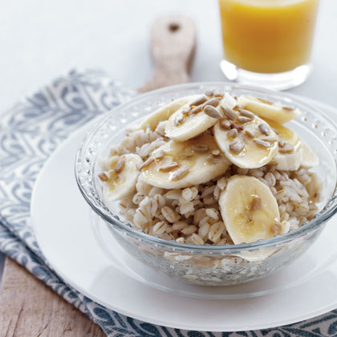

Ingredients
- 2/3 cup water
- 1/3 cup uncooked quick-cooking pearl barley
- 1 banana, sliced
- 1 tablespoon unsalted salted sunflower seeds
- 1 teaspoon honey

Preparation
1. Combine 2/3 cup water and barley in a small microwave-safe bowl. Microwave on HIGH 6 minutes.
2. Stir and let stand 2 minutes.
3. Top with banana slices, sunflower seeds, and honey.

Banana & Almond Butter Toast

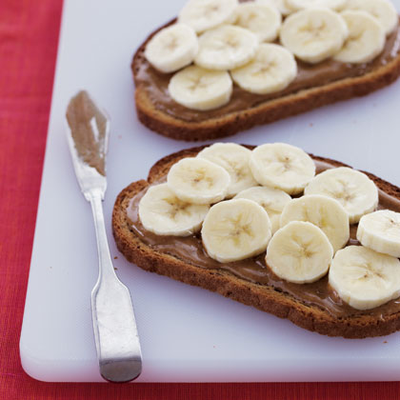
Ingredients
1 tablespoon almond butter
1 slice rye bread, toasted
1 banana, sliced

Preparation
1. Spread almond butter on toast.
2. Top with banana slices.

Greek Yogurt Fruit Parfait
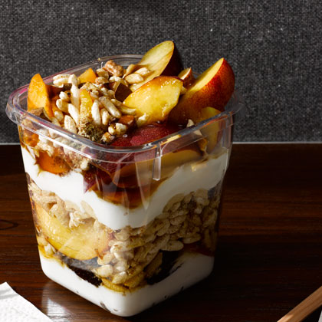

Ingredients
3/4 cup fat-free plain Greek yogurt
2 cups sliced mixed plums, peaches, and nectarines
3/4 cup puffed rice cereal
2 tablespoons walnuts and almonds, toasted and chopped
1 tablespoon ground flaxseed
1 tablespoon maple syrup, agave nectar, or honey

Preparation
In a tall 4-cup container or jar, layer half of the yogurt, fruit, cereal, nuts, flaxseed, and syrup. Repeat with the remaining half of ingredients, ending with syrup. (If you prefer a crunchy parfait, pack cereal separately to add right before eating.) Refrigerate up to 5 hours.

Spiced Green Tea Smoothie
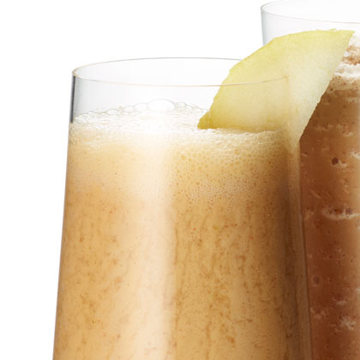

Ingredients
3/4 cup strong green tea, chilled
1/8 teaspoon cayenne pepper
Juice of 1 lemon (2-3 TBSP)
2 teaspoons agave nectar
1 small pear, skin on, cut into pieces
2 tablespoons fat-free plain yogurt
6-8 ice cubes

Preparation
Put all ingredients in blender. Blend until smooth. Drink cold.

