Chocolate self-saucing pudding
There is no better way to warm up on a cold winter's night than a warm sticky chocolate pudding.
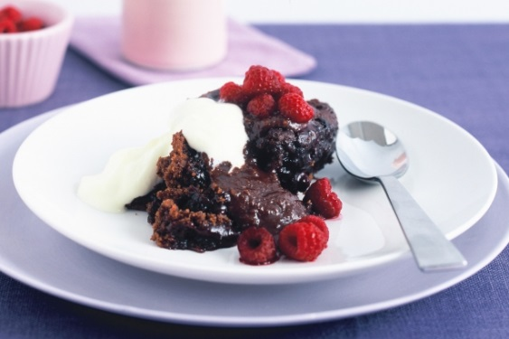
Ingredients
- 1 cup self-raising flour
- 2 tablespoons cocoa powder
- 1/2 cup brown sugar
- 80g butter, melted, cooled
- 1/2 cup milk
- 1 egg, lightly beaten
- thick cream and berries, to serve

Sauce
- 3/4 cup brown sugar
- 2 tablespoons cocoa powder, sifted
- 1 1/4 cups boiling water
Method
Step 1 Preheat oven to 180°C. Grease an 8-cup capacity ovenproof baking dish. Sift flour and cocoa into a large bowl. Stir in sugar.
Step 2 Combine butter, milk and egg in a jug. Slowly add to flour mixture, whisking until well combined and smooth. Spoon into baking dish. Smooth top.
Step 3 Make sauce: Sprinkle combined sugar and cocoa over pudding.
Step 4 Slowly pour boiling water over the back of a large metal spoon to cover pudding. Place dish onto a baking tray. Bake for 35 to 40 minutes or until pudding bounces back when pressed gently in centre. Serve hot with cream and berries.

(Taste.com, 2014)

Apple crumble
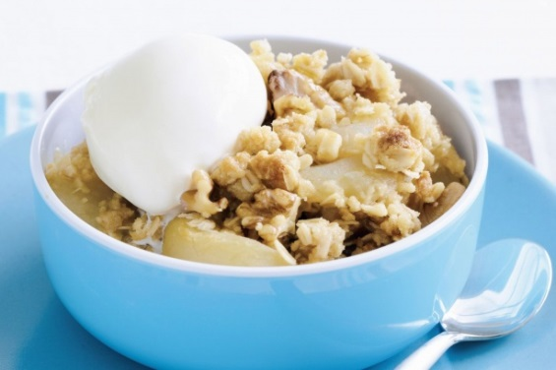
Ingredients
- 150g (1 cup) plain flour
- 100g (1/2 cup, firmly packed) brown sugar
- 100g chilled butter, chopped
- 50g (1/2 cup) rolled oats
- 60g (1/2 cup) chopped walnuts
- 1 x 800g can baker's apple
- Vanilla ice-cream, to serve
Method
Step 1
Preheat oven to 180°C. Combine the flour, sugar, butter and oats in a bowl.
Step 2
Use your fingertips to rub the butter into the flour mixture until the mixture resembles fine breadcrumbs. Stir in the walnuts.
Step 3
Spoon the apple into a 1.5L (6-cup) capacity ovenproof dish. Scatter the walnut mixture evenly over the apples. Bake in oven for 20-25 minutes or until golden. Spoon the apple crumble into serving bowls. Serve with ice-cream.

(Taste.com, 2014)

10-minute honey cheesecake
Don't spend hours on preparing an elaborate dessert when you can make this 10 minute mini cheesecake instead.
Ingredients
- 2 butternut snap biscuits
- 250g block cream cheese, softened
- 1/4 cup honey
- 12 shortcrust pastry tartlets (see note)
- 300ml tub thickened cream, whipped
Method
Step 1 Place biscuits in a small food processor. Pulse until fine crumbs form.
Step 2 Using an electric mixer, beat cream cheese and honey until smooth.
Step 3 Spoon cheese mixture between pastry cases. Spoon cream into a piping bag fitted with a 1cm fluted nozzle. Pipe cream over cream cheese mixture. Sprinkle with the biscuit crumbs. Serve immediately.
(Taste.com, 2014)

