Srilankan Vegie Curry

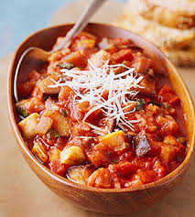
Ingredients
- 1 cup washed red lentils
- 1-2 onions chopped finely
- 2-3 garlic cloves crushed
- 1 large white potato cubed (large)
- 1 carrot chopped thickly
- Sweet potato cubed (large)
- Pumpkin cubed (large)
- Beans, zucchini, broccoli (sliced/cubed/pieces)
- 6 tsp curry paste (or to taste)
- Vegie stock cube
- 3-4 cups water (or more)
- Coconut milk/cream (optional)
- Salt and pepper to taste
- 1 can rinsed chick peas
- Rice to serve
Method
Fry onions till golden add garlic and curry paste and fry for 1 minute. Add water and stock cubes, lentils, carrots, potato and simmer on low for 10 minutes. Add sweet potato cook for another 10 minutes. Add rest of ingredients and cook without lid to reduce liquid. Add coconut milk and chick peas and simmer for 5 minutes. Serve with rice
Note: stir mixture occasionally as it may stick and burn on bottom.

Sticky Kicking Chicken - Jamie Oliver
Cook time 15
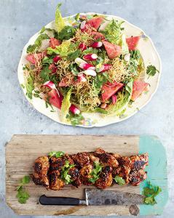
Yield 4 servings

Ingredients
- Salad
- 200g thin rice noodles sesame oil
- 800g watermelon
- 2 little gem lettuces
- 1 handful of radishes
- Half a bunch of fresh mint
- Half a bunch of fresh coriander
- Chicken
- 8 skinless, boneless chicken thighs
- 1 tbsp Chinese five-spice
- olive oil
- 2 tbsp sweet chilli sauce
- 2 tbsp sesame seeds
- Dressing
- 2 tbsp low-salt soy sauce
- 1 tbsp fish sauce
- Half a fresh red chilli
- Half a thumb-sized piece of ginger
- 2 spring onions
- 2 limes
- 1 small clove of garlic

Method
In a bowl, fully submerge the noodles in boiling water.
On a large sheet of greaseproof paper, toss the chicken with salt, pepper and the five-spice. Fold over the paper, then bash and flatten the chicken to 1.5cm thick with a rolling pin. Put into the large frying pan with 1 tablespoon of olive oil, turning after 3 or 4 minutes, until nicely charred and cooked through.
Drain the noodles and toss with 1 tablespoon of sesame oil on a big serving platter. Put half of the noodles into the medium frying pan, tossing regularly until nice and crunchy.
Remove the watermelon skin, cut the flesh into erratic chunks and add to the platter. Trim the lettuces and cut into small wedges, halve the radishes, finely slice the top leafy half of the mint and most of the top leafy half of the coriander, and scatter over the platter.
Put the coriander stalks into the liquidizer with the soy and fish sauces, chilli, peeled ginger, trimmed spring onions, a splash of water, 1 tablespoon of sesame oil and the lime juice. Squash in the unpeeled garlic through a garlic crusher, then whiz until smooth.
Drain away any excess fat from the chicken pan, put back on the heat, drizzle with the sweet chilli sauce and toss with the sesame seeds.
Pour the dressing over the salad and toss gently with clean fingers until well coated, then break over the crispy noodles.
Transfer the chicken to a board and serve with an extra sprinkling of coriander leaves.
(Oliver, 2014)

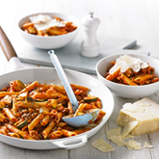
Sausage Bolognese

Cook and enjoy this tasty pasta dish of Sausage Bolognese in just 15 minutes.
Cook Time | 15 minutes (Including prep time)
Serves | Serves 4

Ingredients
- 375 g Garofalo Penne Ziti Rigate
- 1 tbsp Coles Brand Pure Olive Oil
- 500 g pkt Coles Brand Italian Pork Sausages, skins removed
- 1 red onion, chopped
- 1 zucchini, quartered and sliced
- 575 g jar Leggo’s Bolognese Chunky Pasta Sauce
- 40 g shaved parmesan

Method

- Cook the pasta in a large pan of salted boiling water following packet directions. Drain.
- Meanwhile, heat the oil in a deep frying pan over high heat. Cook the sausage meat, breaking up with a wooden spoon, for 4-5 minutes or until browned. Use a slotted spoon to transfer to a bowl. Cook the onion and zucchini for 3-4 minutes or until tender. Return the sausage meat to the pan with the pasta sauce. Simmer for 1 minute or until heated through. Add the pasta and toss to combine.
- Divide the pasta mixture among bowls and sprinkle with parmesan.

(Coles, 2014)

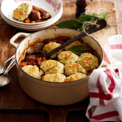
Classic Beef Stew with Dumplings
The ultimate comfort dish, absolutely perfect on a cold winters eve.
Prep Time | 20 minutes
Cook Time | 1 hour 40 minutes
Serves | 6-8Serves 6-8
Ingredients
- 2 tblsp Oil
- 1 kg Chuck Steak, trimmed, cuded
- 1/4 cup Seasoned Flour
- 6 rashers Rindless Bacon, chopped
- 6 Pickling Onions, halved
- 2 Garlic Cloves, crushed
- 1 cup Beef Stock
- 1 cup Red Wine
- 2 Carrots, chopped
- 2 stalks Celery, chopped
- 1 Large Swede, chopped
- 4 sprigs Thyme
- 2 Bay Leaves

Dumplings
- 1 cup Self-Raising Flour
- 50 g Butter, diced
- 1 Egg, lightly beaten
- 1/4 cup Milk
- 2 tblsp Parsley, finely chopped
- 2 tsp Horseradish Cream
- 2 tblsp Parmesan, finely grated

Method
- Preheat oven to moderate, 180C. Heat half the oil in a flameproof casserole dish on high.
- Dust beef in flour, shaking off excess. Brown beef in 2 batches for 2-3 minutes each. Transfer to a plate.
- Heat remaining oil in same pan on medium. Saute bacon, onion and garlic for 4-5 minutes, until bacon is golden. Return beef to pan with stock, wine, carrots, celery, swede and herbs. Bring to the boil on high. Bake, covered, for 1 hour.
- Dumplings: Meanwhile, sift flour into a bowl with seasonings to taste. Rub in butter using fingertips until mixture resembles fine breadcrumbs. make a well in the centre. Stir in combined egg, milk, pasley and horseradish cream. Drop tablespoons of mixture about 2cm apart on top of stew. Sprinkle with parmesan.
- Bake, uncovered, for 20-25 minutes, until dumplings are golden and cooked through.

(Coles, 2014)

All-American Chilli
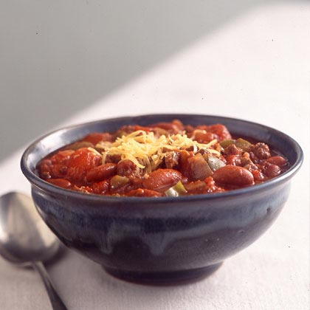
Ingredients
6 ounces hot turkey Italian sausage
2 cups chopped onion
1 cup chopped green bell pepper
8 garlic cloves, minced
1 pound ground sirloin
1 jalapeño pepper, chopped
2 tablespoons chili powder
2 tablespoons brown sugar
1 tablespoon ground cumin
3 tablespoons tomato paste
1 teaspoon dried oregano
1/2 teaspoon freshly ground black pepper
1/4 teaspoon salt
2 bay leaves
1 1/4 cups Merlot or other fruity red wine
2 (28-ounce) cans no-salt-added whole tomatoes, undrained and coarsely chopped
2 (15-ounce) cans no-salt-added kidney beans, drained
1/2 cup (2 ounces) shredded reduced-fat sharp cheddar cheese
Preparation
Heat a large Dutch oven over medium-high heat. Remove casings from sausage. Add sausage, onion, and the next 4 ingredients (onion through jalapeño) to pan; cook 8 minutes or until sausage and beef are browned, stirring to crumble.
Add chili powder and the next 7 ingredients (chili powder through bay leaves), and cook for 1 minute, stirring constantly. Stir in wine, tomatoes, and kidney beans; bring to a boil. Cover, reduce heat, and simmer 1 hour, stirring occasionally.
Uncover and cook for 30 minutes, stirring occasionally. Discard the bay leaves. Sprinkle each serving with cheddar cheese.
Note: Like most chilli’s, this version tastes even better the next day.

