Grilled chicken and spring vegetable wraps
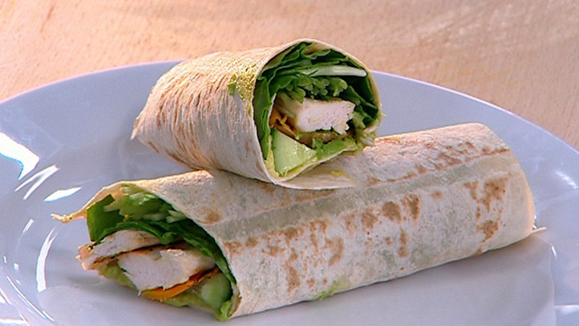

Serves 16

Prep: 10mins

Cooking: 15 – 20mins

Ingredients
8 pieces of mountain bread whole meal
400g chicken breast steamed or grilled, without fat
1 cup Jap’ pumpkin, finely sliced
1 tsp. olive oil
1 tsp. cracked pepper
1/2 avocado, sliced
2 cups of baby spinach
1 cucumber sliced into half moons
1 cup snow pea sprouts
½ red onion, finely sliced
½ bunch of mint

Method
Char-grill the pumpkin over a high heat until tender when pierced with a fork. Allow to cool. Lay each piece of bread flat and top first with chicken slices then follow with the other ingredients. Roll firmly and wrap in cling film or pack firmly in a lunch box.
(Taste.com, 2014)

Lunch Slices topped with salmon and cucumber
Arnott's product: Vita-Weat slices
Prep time: 5 min
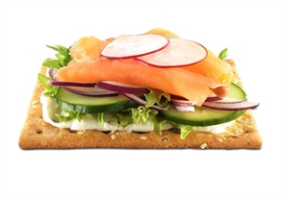
Cooking time: None
Chill time: None
Serves: 1

Ingredients
- Cream cheese
- Lettuce
- Cucumber
- Spanish onion
- Salmon
- Vita Weat

(Arnott’s, 2014).

Crisp Chickpea Slaw
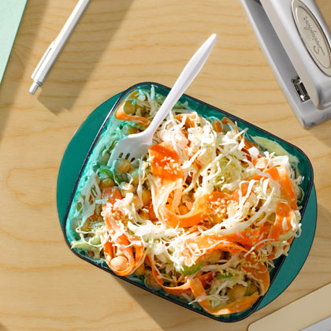
Ingredients
1/4 cup fat-free plain yogurt
1 tablespoon cider vinegar
1 tablespoon water
1/4 teaspoon kosher salt
Freshly ground black pepper
1 (15-oz) can low-sodium chickpeas, rinsed and drained
2 1/2 cups sliced packed green cabbage
2 stalks celery, thinly sliced
2 carrots, peeled with a vegetable peeler into strips or thinly sliced, or 2 cups shredded carrots
2 tablespoons sesame seeds, toasted

Preparation
1. In a medium bowl, stir together the yogurt, vinegar, water, salt, and pepper to taste. Add the chickpeas, cabbage, celery, and carrots; toss to combine. Sprinkle with sesame seeds.
2. Transfer slaw to a plastic food-storage bag or 2 portable containers. Refrigerate at least 4 hours before serving; slaw keeps up to 3 days.

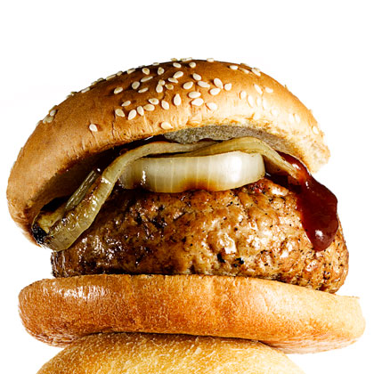
BBQ Turkey Burgers
Ingredients
1 pound ground dark-meat turkey
1 garlic clove, minced
1/2 teaspoon paprika
1/4 teaspoon ground cumin
Pinch of kosher salt
1/4 teaspoon freshly ground black pepper
4 slices sweet onion, grilled
1/4 cup barbecue sauce
4 (1.6-oz) sesame seed buns, toasted

Preparation
1. In medium bowl, gently mix together turkey, garlic, paprika, and cumin.
2. Form turkey into 4 (4-inch) patties; season with salt and pepper.
3. Heat grill to medium-high; cook, turning once, until burgers are just cooked through (about 7 minutes per side). Serve with desired toppings and bun

Curried Egg Salad Sandwich
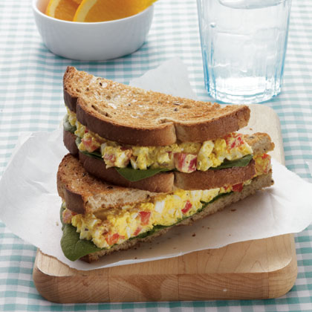
Ingredients
2 hard-cooked eggs, chopped
2 tablespoons plain Greek-style low-fat yogurt
2 tablespoons chopped red bell pepper
1/4 teaspoon curry powder
1/8 teaspoon salt
1/8 teaspoon pepper
2 slices rye bread, toasted
1/2 cup fresh spinach
1 orange
Preparation
1. Combine eggs, yogurt, bell pepper, curry powder, salt, and pepper, in a small bowl; stir well.
2. Place spinach on rye bread, top with egg salad, and serve the orange on the side.

